**Nimish Birla**

**Batch-2**

**Emp ID- 655069**

**Power BI Hands-on Assessment**

**Scenario:** Sales Performance Analysis with Power BI In this scenario, let's imagine you work for a retail company, and you've been tasked with analyzing the sales performance of your products and stores using Power BI. You have multiple data sources and tables to work with, and your goal is to provide actionable insights to improve sales strategies.

Data Sources:

• Sales Transactions Data: Contains information about each sale, including product ID, store ID, date, quantity sold, and revenue generated.

• Product Data: Includes details about each product, such as product ID, name, category, and price.

• Store Data: Provides information about the stores, including store ID, location, and store manager.

Requirement 1: Data Loading

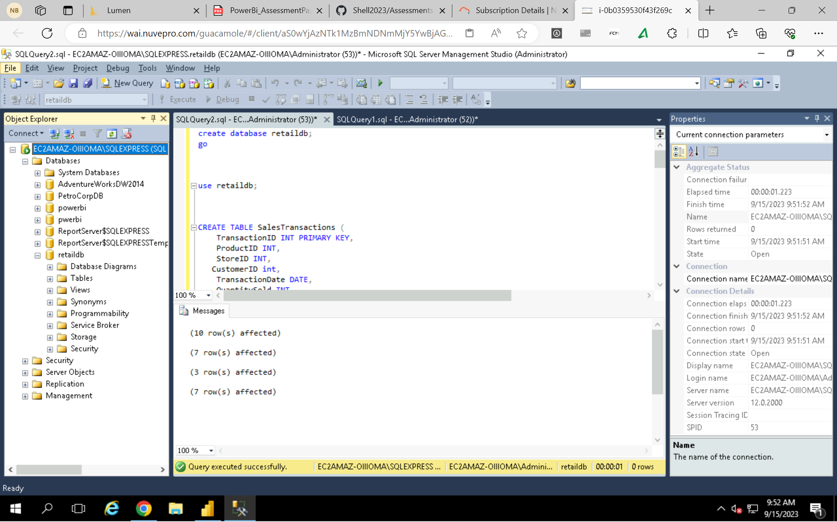

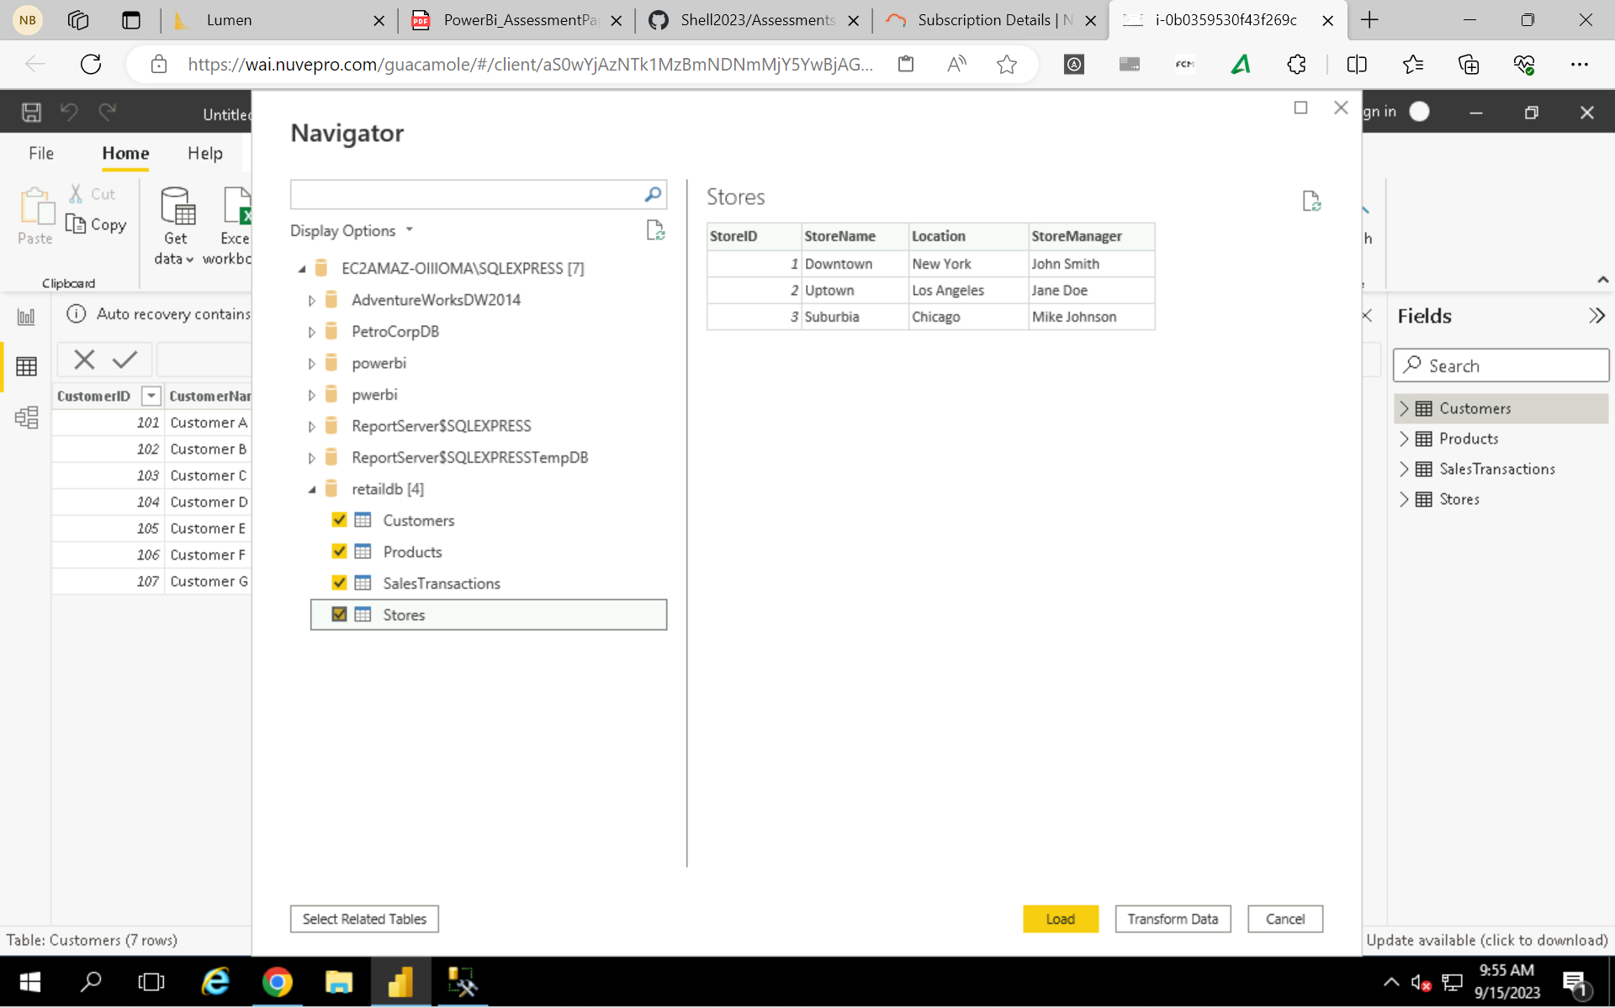

Requirement 2: Data Transformation

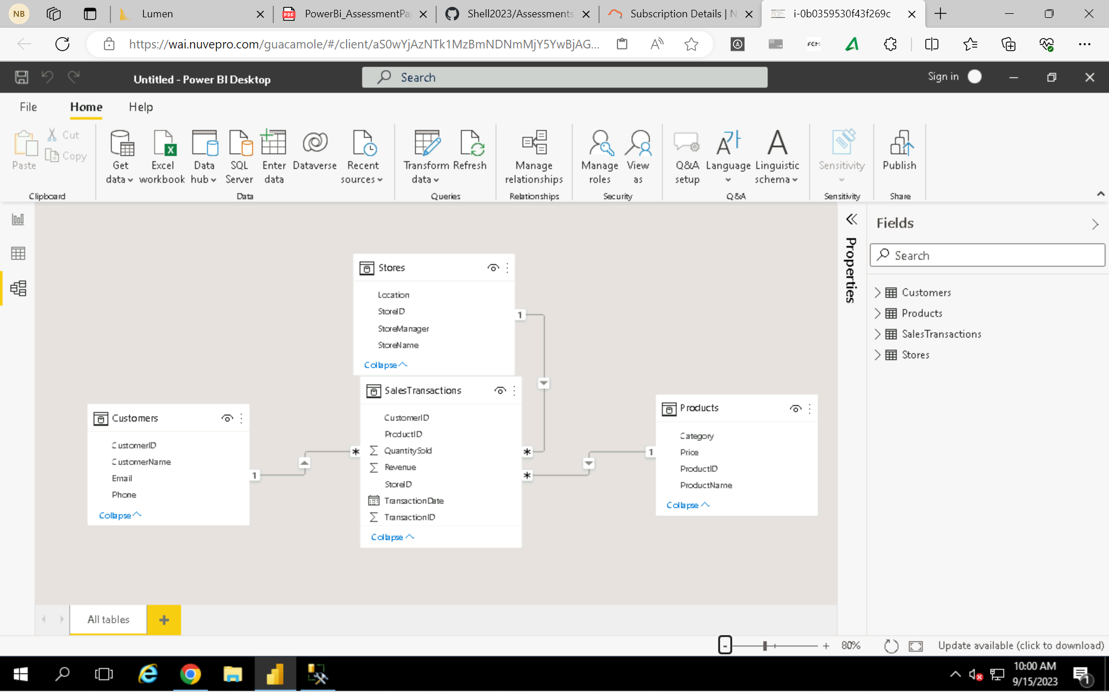

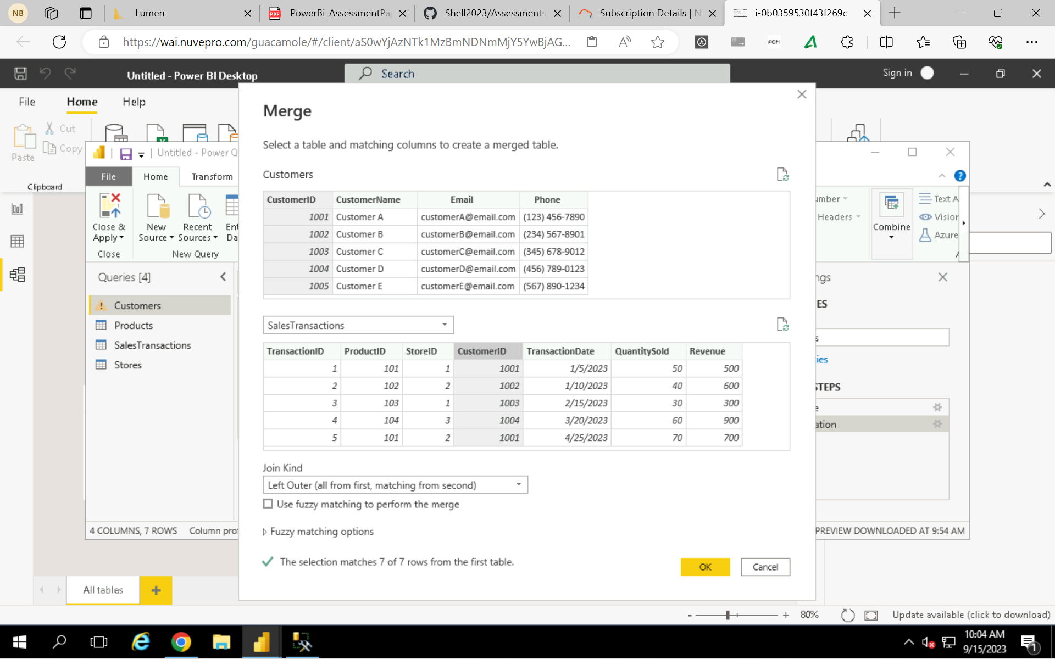

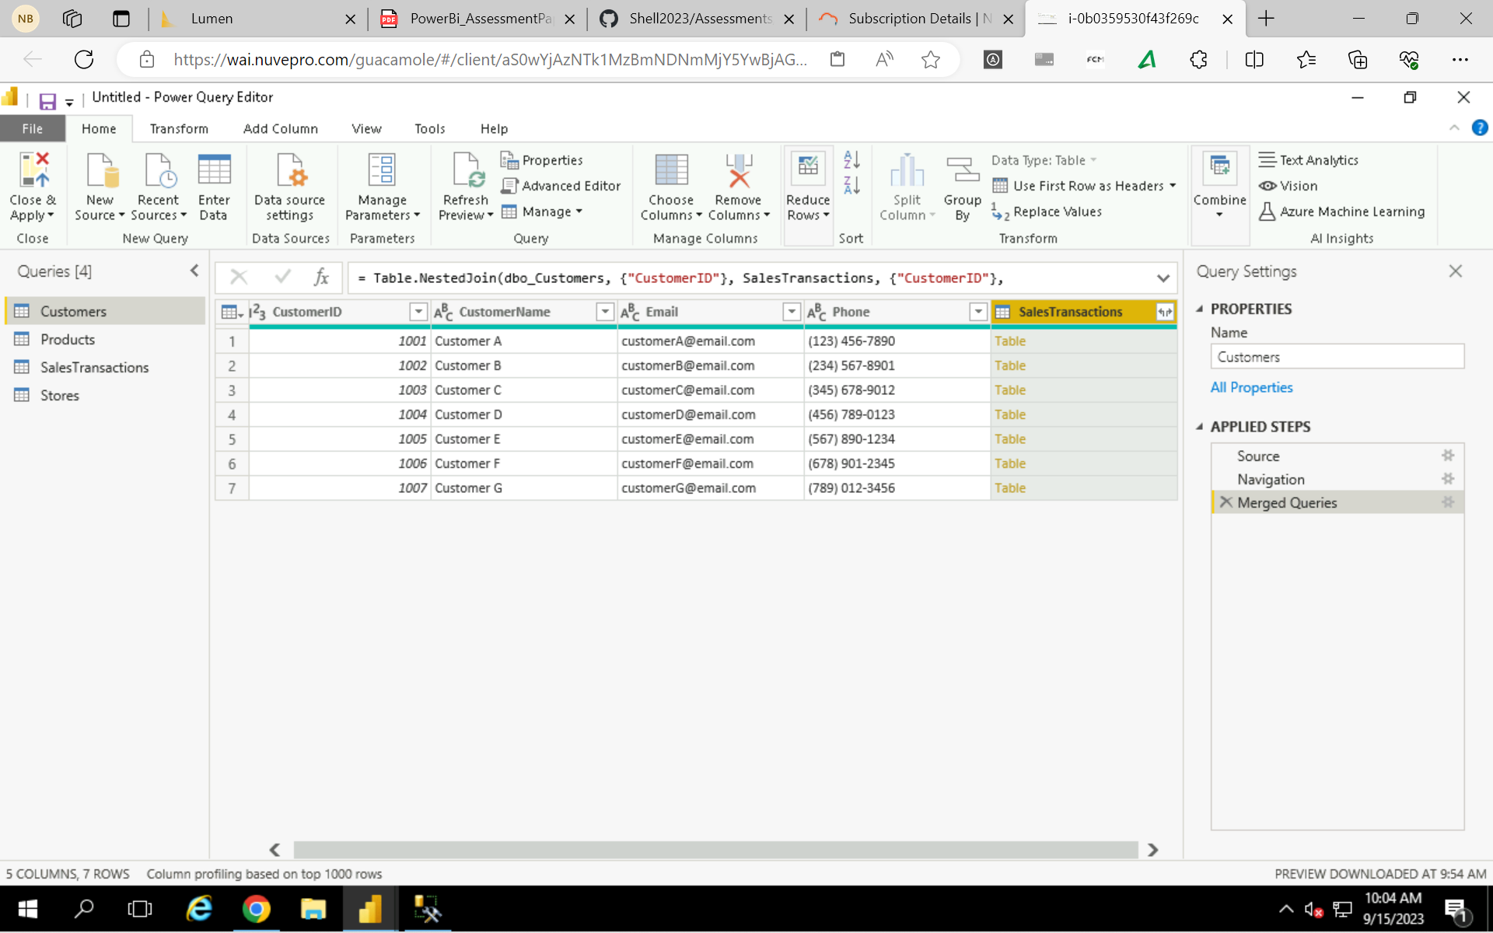

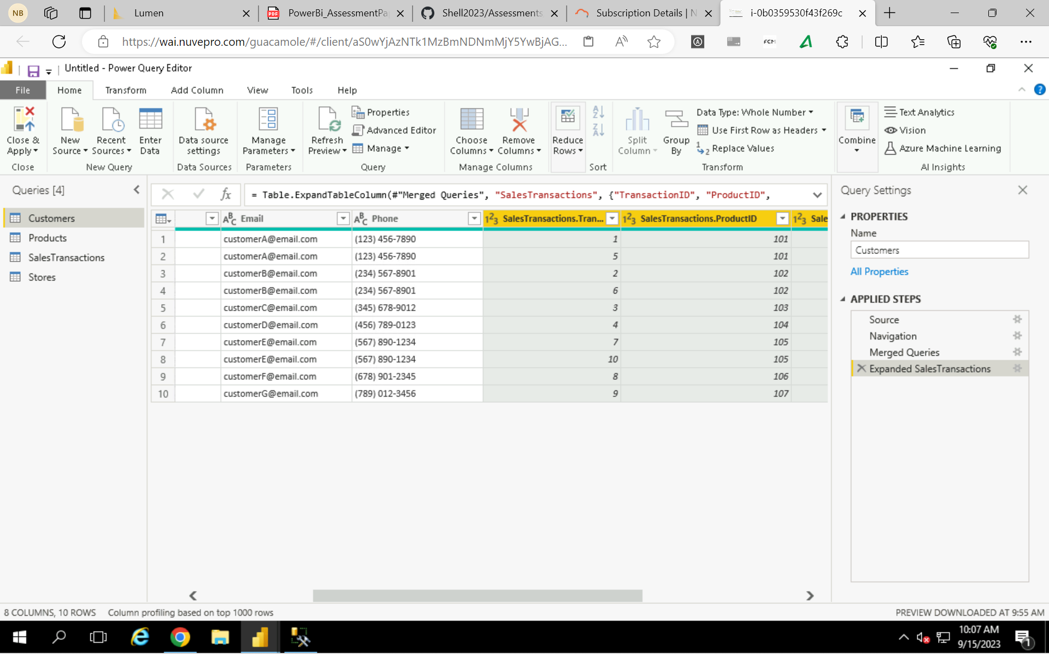

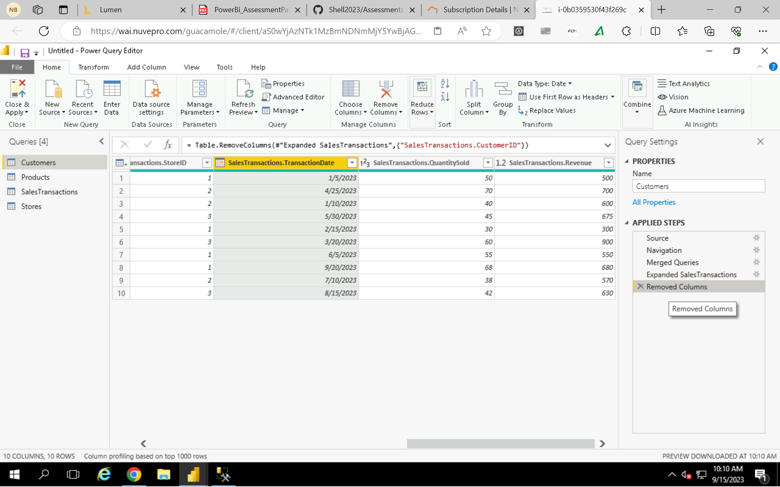

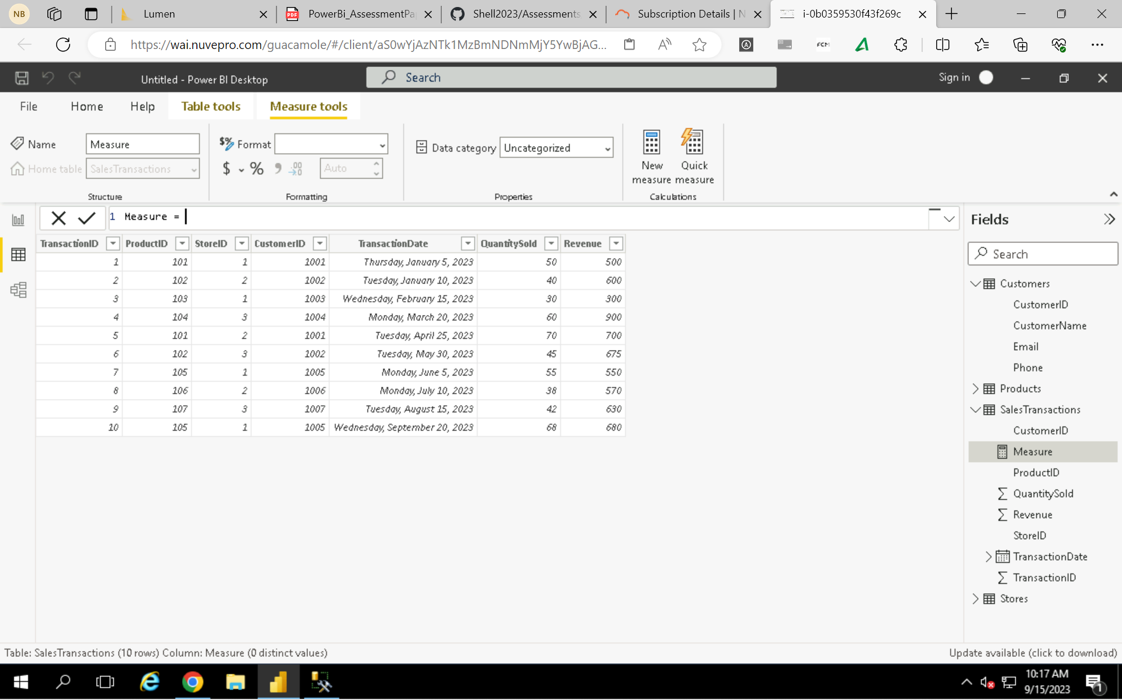

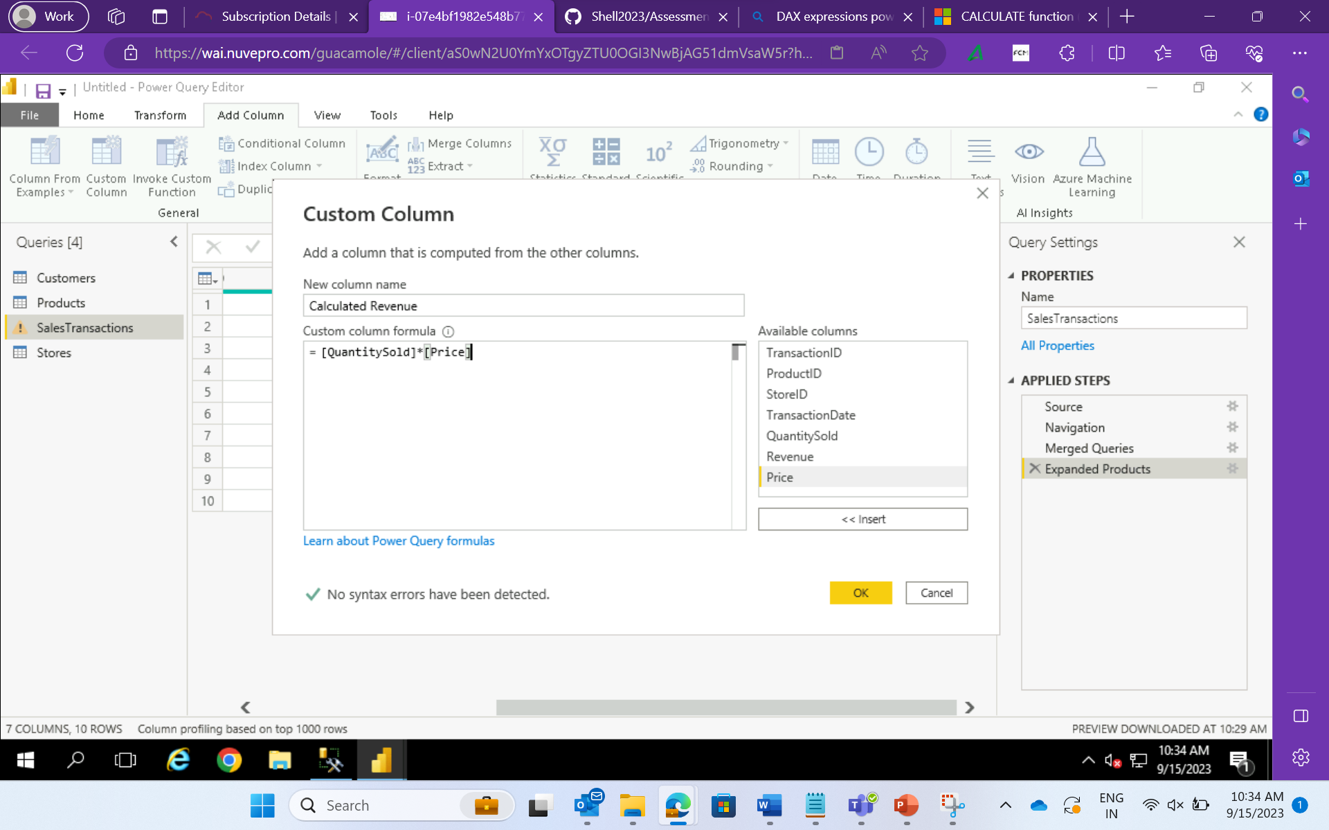

Requirement 3: Data Modelling

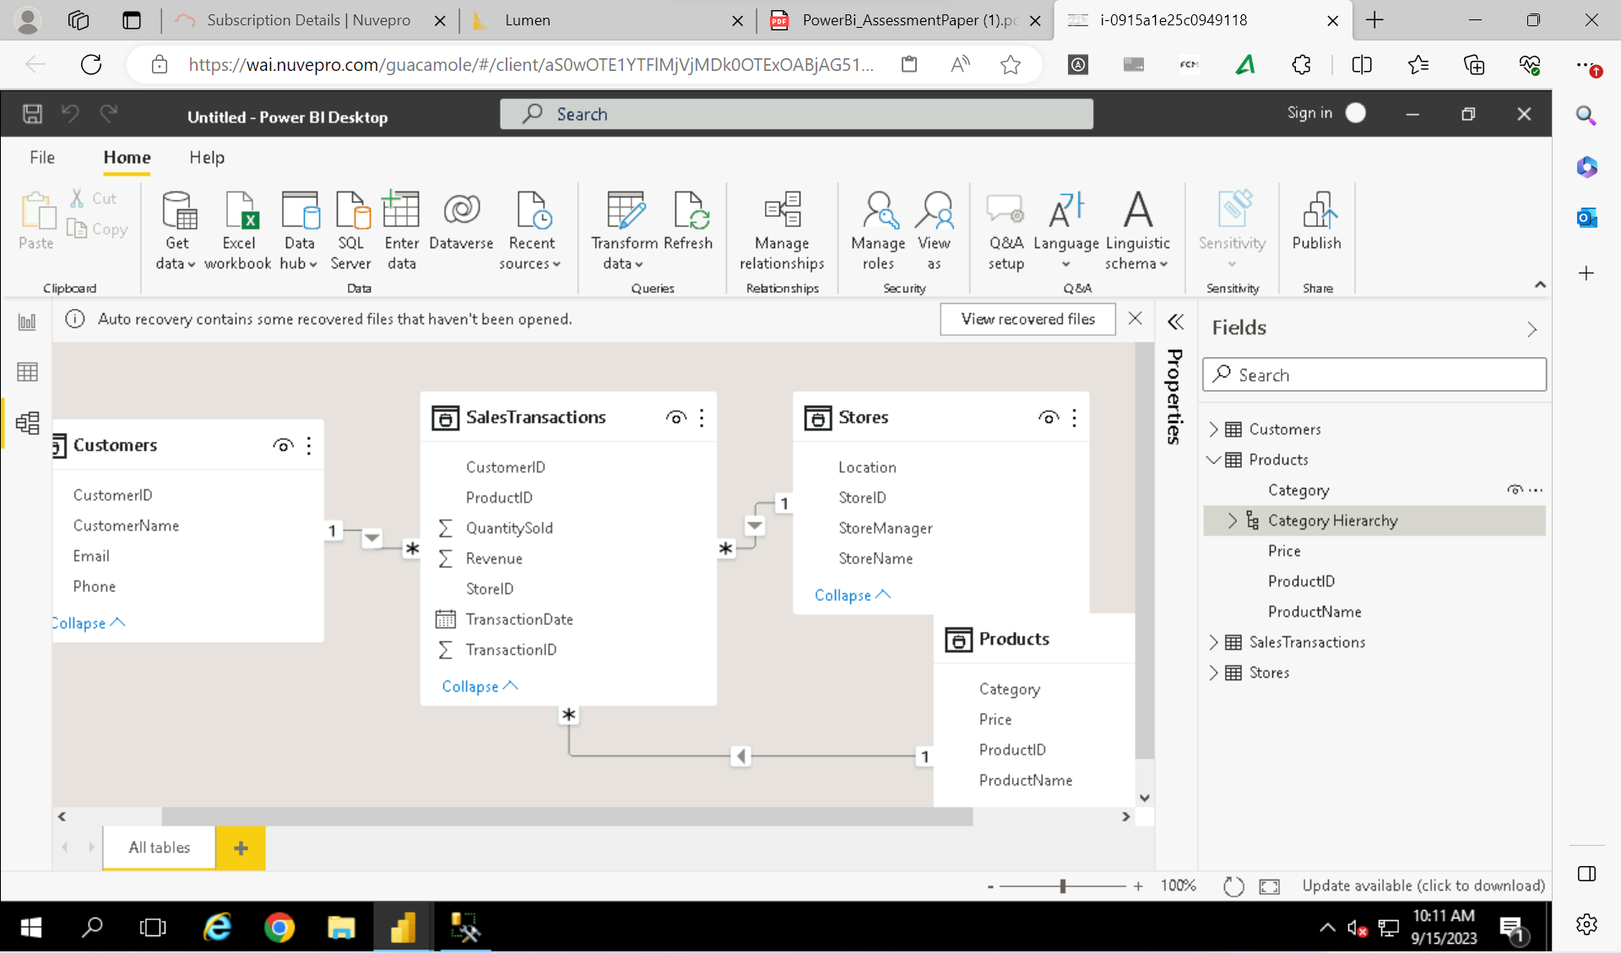

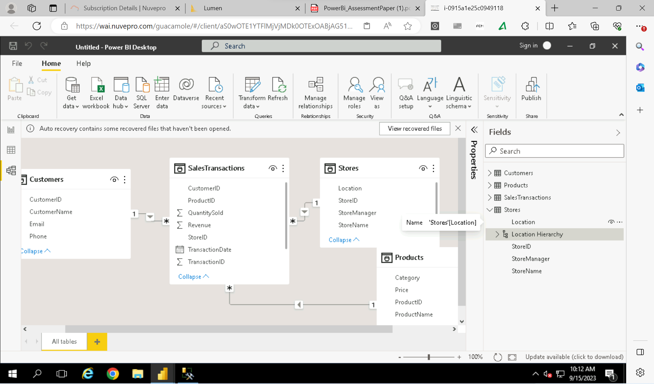

Requirement 4: Business Queries and Analysis

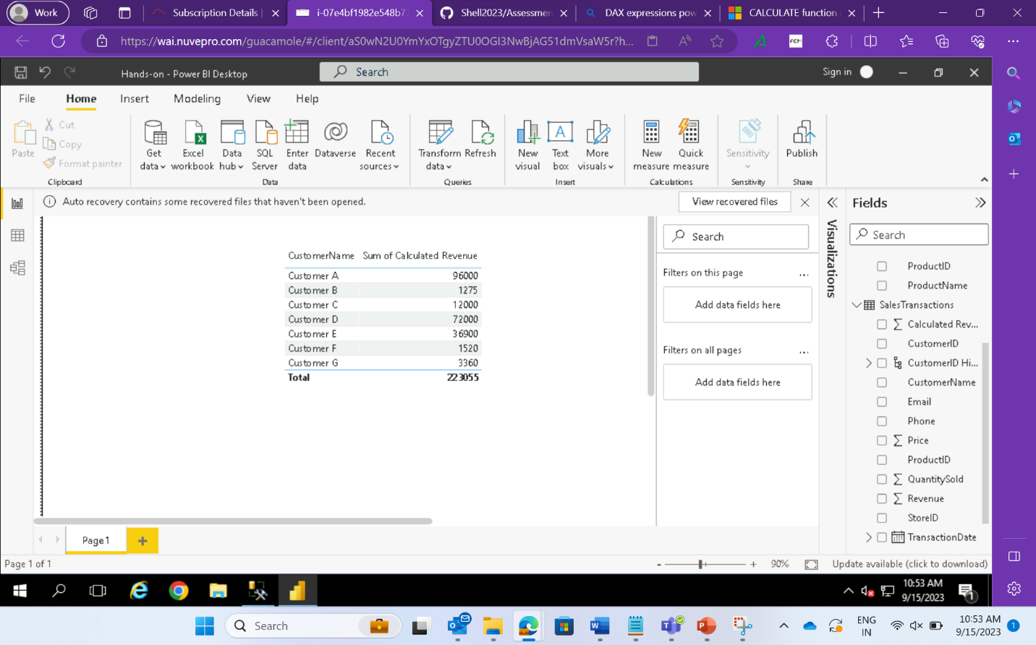

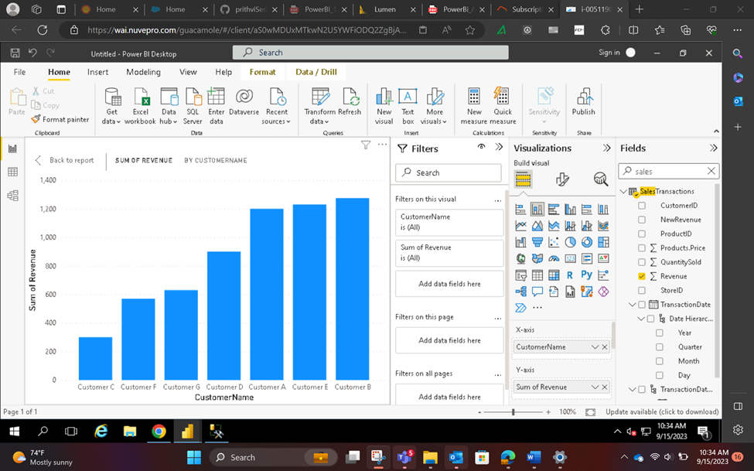

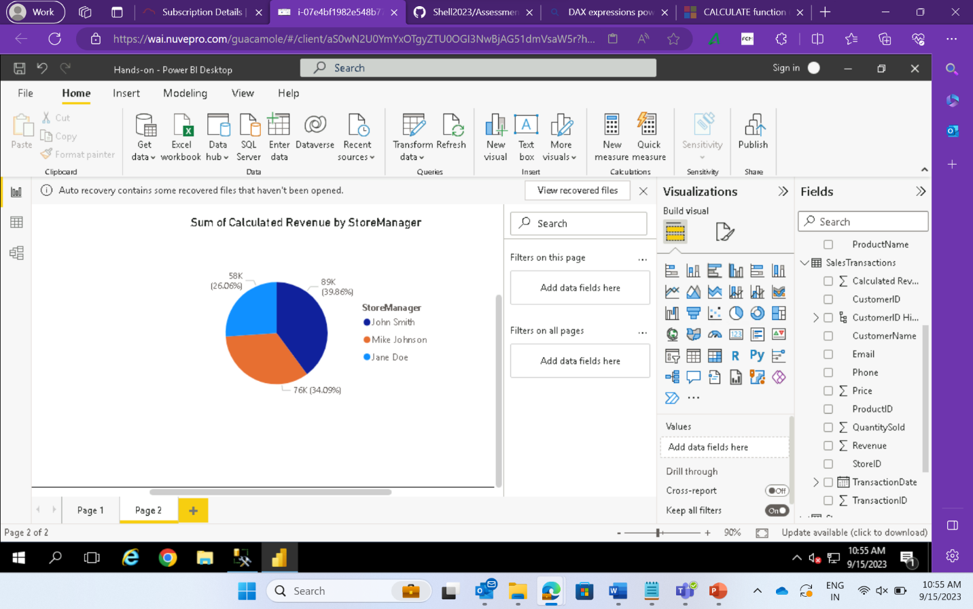

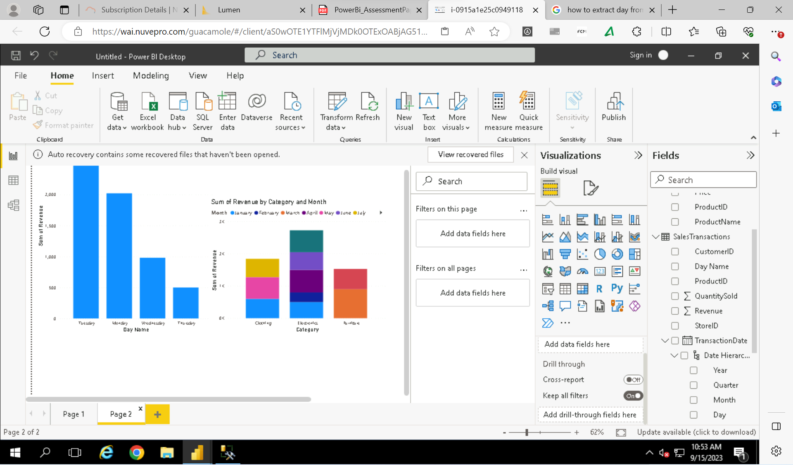

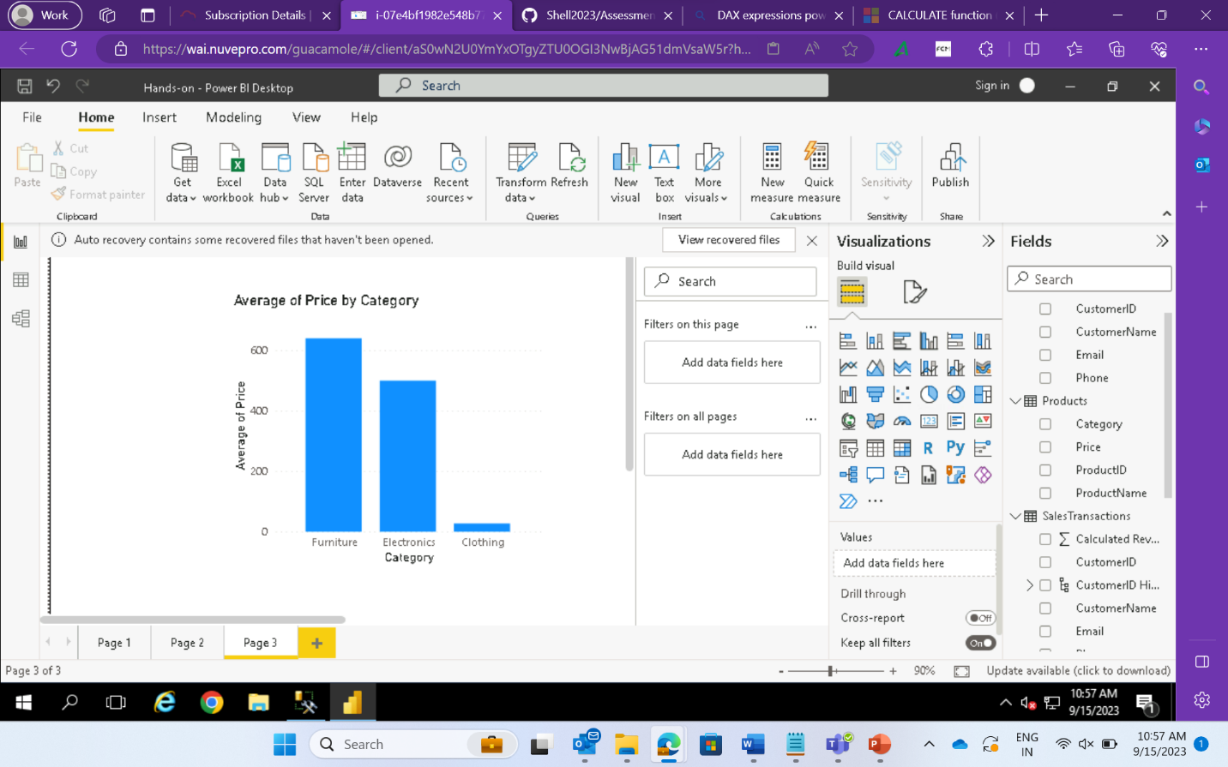

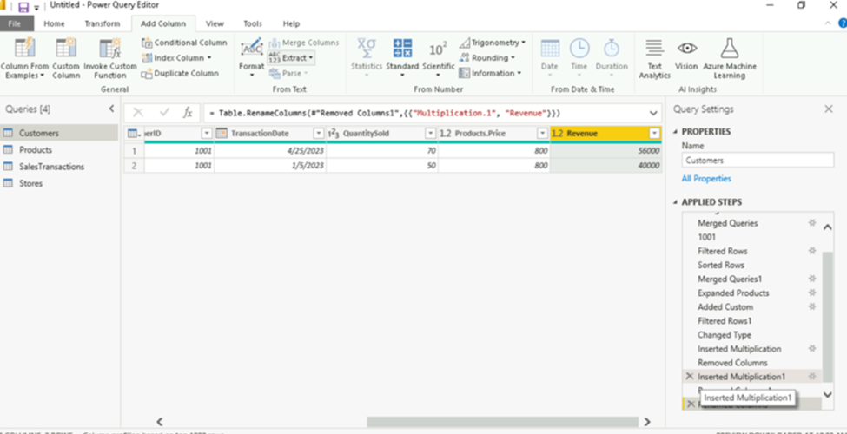

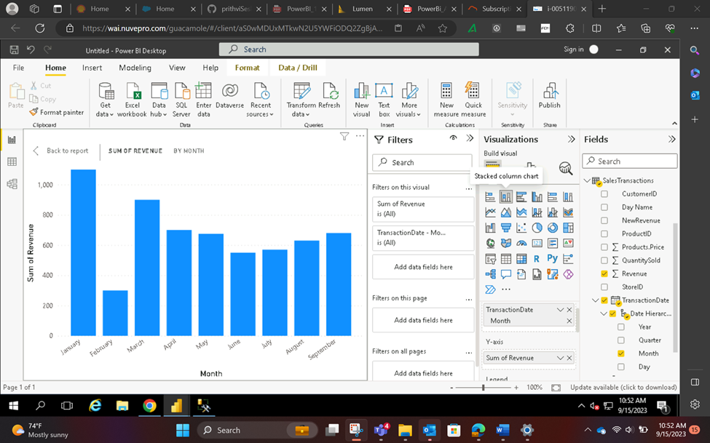

Requirement 5: Data Insights and Recommendations

